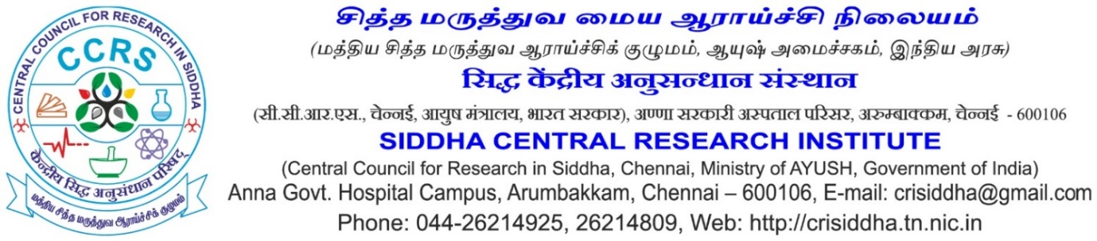
Recent Passport Size photo
Application for the Post of Therapist (Siddha)
Project -“A single center randomized parallel group clinical trial to compare the efficacy of Siddha Varmam Therapy and Thailam Application (SVT) versus Thailam Application (TA) in terms of pain and disability in the treatment of Kumbavatham (Adhesive capsulitis)”
 | Name in full (in CAPITAL letters) (Enter the name as given in Matric/SSLC Certificate. If there is any change in the name, including initials, attach documentary proof)
 | Gender
 | Father’s/Husband’s name
 | Date of birth (as entered in Matric/SSLC/HSC) &  Age as on closing date for receipt of application | _____Years____Months____Days
 | Whether belongs to SC/ST/OBC/UR (Enclose a copy of the certificate from the Competent Authority, if applicable)
 | Are you a physically challenged person? | Yes/ No
Address in CAPITAL letter with PIN code
Permanent:

Correspondence:

 | E-mail Id: (Mandatory)
 | Mobile/landline phone No.:

10) Educational Qualifications

No | Exam Passed | Board/ University | Years of Passing | % of Marks

11) Experiences

Sl. No | Name of the Institution | Name of employment * | Date of Joining | Date of leaving | Yrs | Months | Days
Total

*Provide certificate of proof in support of your claim

12) Any Other information – (Attach separate sheet, if space is not enough)

I hereby declare that the information furnished above is true, complete and correct to the best of my knowledge and belief. I understand that in the event of any of the information provided by me are found false or incorrect at any stage, my candidature / appointment shall be liable for cancellation / termination without notice or any compensation in lieu thereof.

Place:

Date: Signature &Name of the Candidate

