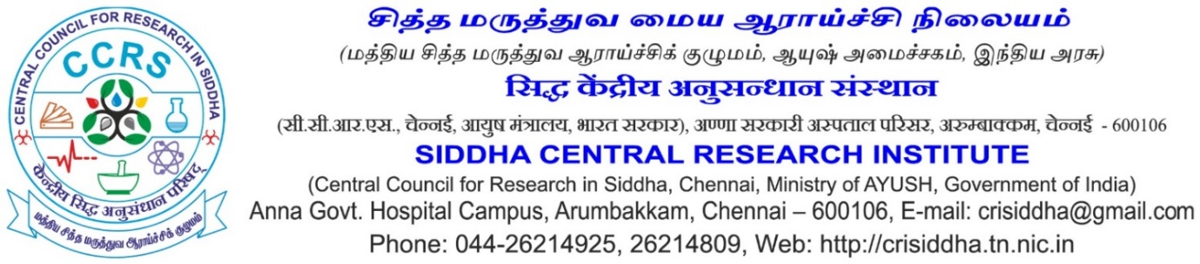
Recent Passport Size photo
Application for the Post of Sociologist
Project “An open randomized Double Arm Clinical Trial to Evaluate and Compare the Efficacy of Siddha Herbal Formulations ‘ Venpoosani Nei’ (Internal) versus ‘ Venpoosani Nei with Thiripala Chooranam Wash (External) in ‘ Vellai Noi’’
 | Name in full (in CAPITAL letters) (Enter the name as given in Matric/SSLC Certificate. If there is any change in the name, including initials, attach documentary proof)
 | Gender
 | Father’s/Husband’s name
 | Date of birth (as entered in Matric/SSLC/HSC) &  Age as on closing date for receipt of application | _____Years____Months____Days
 | Whether belongs to SC/ST/OBC/UR (Enclose a copy of the certificate from the Competent Authority, if applicable)
 | Are you a physically challenged person? | Yes/ No
Address in CAPITAL letter with PIN code
Permanent:

Correspondence:

 | E-mail Id: (Mandatory)
 | Mobile/landline phone No.:

10) Educational Qualifications

No | Exam Passed | Board/ University | Years of Passing | % of Marks

11) Experiences

Sl. No | Name of the Institution | Name of employment * | Date of Joining | Date of leaving | Yrs | Months | Days
Total

*Provide certificate of proof in support of your claim

12) Any Other information – (Attach separate sheet, if space is not enough)

I hereby declare that the information furnished above is true, complete and correct to the best of my knowledge and belief. I understand that in the event of any of the information provided by me are found false or incorrect at any stage, my candidature / appointment shall be liable for cancellation / termination without notice or any compensation in lieu thereof.

Place:

Date: Signature &Name of the Candidate

