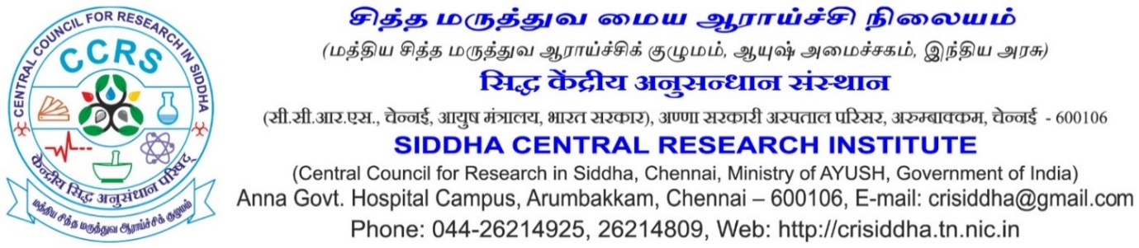

Walk-in-Interview
Walk-in Interview for various posts required in RRDR project will be held on 07.10.2021 at 10.30 a.m. in Siddha Central Research Institute, Anna Govt. Hospital campus, Arumbakkam, Chennai- 600 106 as per details given below. Relaxation will be given to SC/ST/OBC candidates as per GOI Rules. The engagement will be purely on contract basis and no claim for continuation or regular appointment will be entertained. Applicant should bring their original certificates with self-attested xerox copies, Two passport size photos, any photo ID proof with xerox copy. No TA/DA will be paid for attending the walk-in-interview. The Director in-charge reserves all the rights to accept or reject any application/applicant without assigning any reason. Essential Educational Qualification & General Conditions are as under: -
JRF(Chemistry)
Name of the project: RRDR
Work Place : SCRI, Chennai
Name of the post: Junior Research Fellow (Chemistry)
Number of post: One
Period of engagement: Initially 1 year; extendable based on performance and coterminous with the project.
Monthly emoluments: Rs. 31,000 + 24 % HRA
Qualifications and experience:
Essential: MSc in Chemistry/Analytical Chemistry/Inorganic Chemistry
Desirable: (i) One year of Research /Industrial experience in reputed organization.
(ii) Candidates with experience in handling sophisticated instruments such as HPLC/ ICP-OES etc. will be given preference.
Age Limit: Not exceeding 28 years as on 01 /01/2021 (relaxable upto five years in case of candidates belonging to SC/ST, PwBD/VH/OBC candidates and women candidates).
Nature of duties: Analytical development pertaining to herbal substances and monograph preparation.

JRF(Pharmacognosy)
Name of the project: RRDR
Work Place : SCRI, Chennai
Name of the post: Junior Research Fellow (Pharmacognosy)
Number of post: One
Period of engagement: Initially 1 year; extendable based on performance and coterminous with the project.
Monthly emoluments: Rs. 31,000 + 24 % HRA
Qualifications and experience:
Essential: MSc in Botany/Medicinal Plants/ Plant Sciences or M.Pharm in Pharmacognosy.
Desirable: Experience in Pharmacognosy/ Macro- microscopic techniques and skill of drafting scientific documents like research papers/ monographs.
Age Limit: Not exceeding 28 years (relaxable upto five years in case of candidates belonging to SC/ST, PwBD/VH/OBC candidates and women candidates).
Nature of duties: Macro- microscopical studies, preparation of monographs.

JRF(Siddha)

Name of the project: RRDR
Work Place : NIS, Chennai.
Name of the post: Junior Research Fellow (Siddha)
Number of post: One
Period of engagement: Initially 1 year; extendable based on performance and coterminous with the project.
Monthly emoluments: Rs. 31,000 + 24 % HRA.
Qualifications and experience:
Essential: Bachelor of Siddha Medicine and Surgery (BSMS)
Desirable: Candidates with experience in literature collections/literature survey of Indian System of Medicine.
Age Limit: Not exceeding 28 years (relaxable upto five years in case of candidates belonging to SC/ST, PwBD/VH/OBC candidates and women candidates).
Nature of duties: Literature collection/ literature survey in ASU formulations.

Field Attendant (For Survey)

Name of the project: RRDR
Work Place : RRIUM, Chennai.
Name of the post: Field Attendant
Number of post: Two
Period of engagement: Initially 1 year; extendable based on performance and coterminous with the project.
Monthly emoluments: Rs. 15,000 only per month.
Qualifications and experience:
Essential: Higher Secondary (+2) pass with Biology group or botany as one of the subjects.
Desirable: (i) B.Sc., (Botany) with knowledge about Herbarium techniques, Field Collection.
(ii) Interest to work in Field survey in remote forest areas .
Age Limit: Not exceeding 28 years (relaxable upto five years in case of candidates belonging to SC/ST, PwBD candidates, three years in case of OBC).
Nature of duties: To collect raw drugs form remote forest areas, interest in field excursions in remote forest areas and assist JRF in the herbarium preparation and raw drug processing.

Data Entry Operator (For Survey)

Name of the project: RRDR
Work Place : RRIUM, Chennai.
Name of the post: Data Entry Operator.
Number of post: One
Period of engagement: Initially 1 year; extendable based on performance and coterminous with the project.
Monthly emoluments: Rs. 20,000 only per month.
Qualifications and experience:
Essential: Any Degree with Botany as one of the subjects with knowledge in Computer application, Photo shopping work, Experience in Scientific report preparation.
Desirable: (i) B.Sc., or M.Sc., (Botany) with knowledge about Herbarium techniques, Field Collection. Experience in Scientific report preparation.
(ii) Interest to work in Field survey in remote forest areas for field data collection.
(iii) Experience with MS office and data programs, Knowledge of advance Excel, Excellent Typing speed (35 wpm), Good communication skills.
Age Limit: Not exceeding 28 years (relaxable upto five years in case of candidates belonging to SC/ST, PwBD candidates, three years in case of OBC).
Nature of duties: (i) Scientific data Collecting & entering data in databases and maintain accurate records of raw drugs and medicinal plants used in ASUH.
(ii) interest in field excursions in remote forest areas for data collection and assist the JRF in the herbarium data labelling and preparation.

. Director (Scientist-III) I/C

