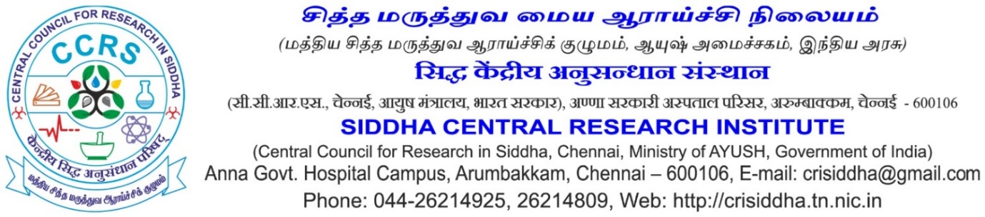
Recent Passport Size photo

Application for the Post of Research Associate (Siddha)

Project : SPC Siddha at CCRS, Chennai

 | Name in full (in CAPITAL letters) (Enter the name as given in Matric/SSLC Certificate. If there is any change in the name, including initials, attach documentary proof)
 | Gender
 | Father’s/Husband’s name
 | Date of birth (as entered in Matric/SSLC/HSC) &  Age as on closing date for receipt of application | _____Years____Months____Days
 | Whether belongs to SC/ST/OBC/UR (Enclose a copy of the certificate from the Competent Authority, if applicable)
 | Are you a physically challenged person? | Yes/ No
Address in CAPITAL letter with PIN code
Permanent:

Correspondence:

 | E-mail Id: (Mandatory)
 | Mobile/landline phone No.:

10) Educational Qualifications

No | Exam Passed | Board/ University | Years of Passing | % of Marks

11) Experiences

Sl. No | Name of the Institution | Name of employment * | Date of Joining | Date of leaving | Yrs | Months | Days
Total

*Provide certificate of proof in support of your claim

12) Publications – peer reviewed only (Attach separate sheet, if space is not enough)

Sl.No | Title of the paper | Name of the Journal | Primary/ co/ corresponding author | Impact factor

13) Books/ Chapter – (Attach separate sheet, if space is not enough)

Sl.No | Title of the Book | ISBN/ RNI | Role: Author/ Editor

13) Any Other information – (Attach separate sheet, if space is not enough)

I hereby declare that the information furnished above is true, complete and correct to the best of my knowledge and belief. I understand that in the event of any of the information provided by me are found false or incorrect at any stage, my candidature / appointment shall be liable for cancellation / termination without notice or any compensation in lieu thereof.
Place:

Date: Signature &
Name of the Candidate

