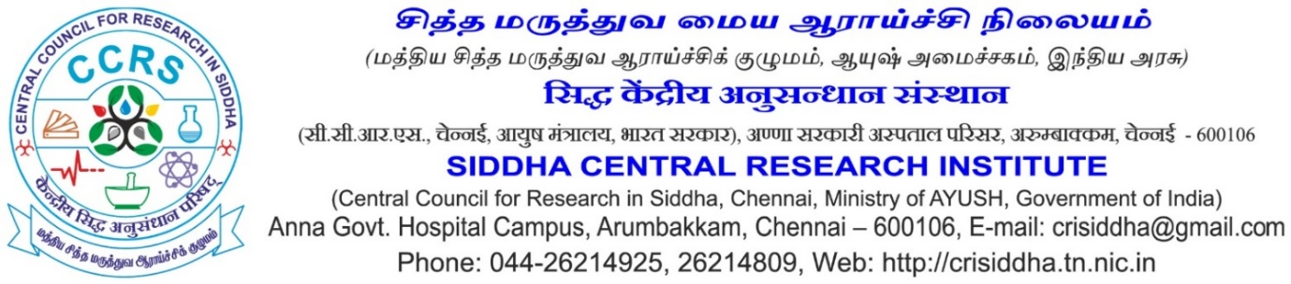
Virtual /Walk-in-Interview-2/2020
Virtual / Walk-in-interview for selection of two posts of Research Associate (Siddha) – One number and Senior Research Fellow (Chemistry)- Two numbers, for the Project “Scheme for outsourcing of scientific work of Pharmacopoeia Commission for Indian Medicine & Homoeopathy (PCIM & H)” will be held on the date to be notified later. The details are given below. Relaxation will be given to SC/ST/OBC candidates as per GOI Rules. The engagement will be purely on contract basis and no claim for continuation or regular appointment will be entertained. The application format is attached herewith. The filled application along with certificates/documents (Scanned copies) may be sent to the email address crisiddha@gmail.com. The attachment should be in PDF. The Director in-charge reserves all the rights to accept or reject any application without assigning any reason. The date of the interview will be notified later by Email / Mobile.
Essential Educational Qualification & General Conditions are as under: -
Research Associate (Siddha) – One number
Educational Qualification: MD (Siddha) in Gunapadam from a CCIM recognized Institution and Enrolment in the Central/ State Register of Indian Medicine/ Siddha.
Desirable Qualification: Experience in drug preparation processes and standardization
Age: not to exceed 40 years, Relaxation will be given to SC/ST/OBC and women candidates as per GOI Rules.
Fellowship: Rs.36, 000/- + HRA as applicable (pre-revised 6th CPC scale)
Period of the project: 1 years or till completion of the project whichever is earlier.
Senior Research Fellow (Chemistry) – Two numbers
Educational Qualification: M.Sc. Chemistry/ Analytical chemistry/Inorganic chemistry with minimum 2 years research/teaching/industrial experience from a recognized University / Institution.
Desirable Qualification: Hands on experience in sophisticated analytical instruments such as HPLC, ICP-OES, IC etc.
Fellowship: Rs.28, 000/- + HRA as applicable (pre-revised 6th CPC scale)
Age: not to exceed 35 years, Relaxation will be given to SC/ST/OBC and women candidates as per GOI Rules.
Period of the project: 1 years or till completion of the project whichever is earlier.

(Dr. P. Sathiyarajeswaran)
Assistant Director I/C

